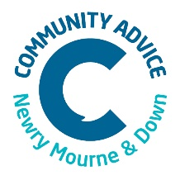
September 2021
Dear Applicant
Role: Trainee Adviser Post
Term: Twelve months ( extension subject to funding)
Salary: £18,200
Location: Ballybot House, Newry.
Full Time 35 Hours per week

Application for position
Please find enclosed
1. Application Form and CV also to be sent.
2. Job Description &Person Specification
3. Guidance Notes
Please be advised this role is a regulated position and therefore the successful applicants will be subject to a confidential Access NI Check.
The closing date for return of completed application forms is Friday 24th September at 12.00 pm.
Applications to be emailed to Kellie@advicenmd.com
Thank you for your interest in this role.
Yours sincerely

Kellie Murray
Senior Coordinator

